Multi-Agency Confirmation of Referral to

Stoke-on-Trent Children’s Social Care

and Targeted Early Help Service

This form should always be completed when making a referral to Stoke-on-Trent Statutory Children’s
Social Care; Safeguarding and Referral Team and Targeted Early Help Service. This is to allow the
sharing of information with other agencies. All urgent child protection referrals should initially be
made by telephone and then confirmed in writing as soon as possible, ideally within 24 hours but
within a maximum timescale of 48 hours using this form.

Contact details: SRT.referrals@Stoke.gov.uk phone number is: 01782235100

Concerns should be discussed with the child’s parents / carers, making them aware that a referral to Stoke-on-Trent Children’s Social Care and / or Early Help Service will be made and gaining consent to do so. This is unless to do so would place the child at risk of significant harm, or any other individual at risk of serious harm, or lead to interference with any potential investigation. The child’s safety and well-being must be the overriding consideration in making any such decisions.

MARF’s WITH INSUFFICIENT INFORMATION WILL BE RETURNED

PLEASE NOTE ALL MARF’s SHOULD BE TYPED NOT HANDWRITTEN

REFERRAL DATE |  | TIME

Who have you spoken to about this referral?
EG; Consultation Line, EH, Line Manager, Designated Safeguarding Lead
What work has your organisation completed with this child/ family prior to this referral?
Signatures | Person Making Referral | Child Protection / Lead Line Manager
Print Name
Signature
Detail of Referrer
Name
Designation
Organisation
Address
Post Code
Email Address
Telephone number/ DD
Are you aware of previous referrals being made regarding this child/ family? | Yes/ No (delete as appropriate) | If Yes, what were the concerns / Issues?

CONSENT
Has consent been obtained to progress this referral to the MASH?  (please select yes or no) | Yes |  | No  Please state why?
Has consent been obtained from the parent / carer to share information?  (please select yes or no) | Yes |  | No  Please state why?
If consent has NOT been obtained, please clearly record the reason/s for this?

(Please note we are unable to progress any section 17 referrals without parental consent, so please endeavour to obtain this. Please note any without consent will be returned)

What service do you require for this family?  (please tick)  (Please note when information is processed the most suitable service will be identified) | Targeted Early Help - Family Support | Statutory Safeguarding - Childrens Social Care
DO YOU CONSIDER THE CHILD /YOUNG PERSON TO BE AT RISK OF IMMEDIATE HARM?
YES |  | NO
Unborn /Child/ Young Person
Child Forename | Child Surname | Gender | DOB/ EDD | NHS Number
If unborn – Hospital that mother is booked into
Address: Include all addresses where children reside |  | Telephone Numbers: Home /Mobile
Ethnic Origin
1st Language
Interpreter Required
Religion / Belief

Parent /Carers details | Person 1 | Person 2
Forename
Surname
DOB
Relationship
Address
Telephone Number/s
First Language
Is an Interpreter /Signer required?

Other Household Members
Forenames | Surname | DOB | Relationship | Contact details  (if known)

Are you aware of any of the following concerns? (tick as appropriate)
Domestic Abuse |  | Substance Misuse |  | Disabilities / Learning Difficulties |  | Neglect
Mental Illness |  | CSE / CCE  (exploitation) |  | Young Carer |  | Private Fostering

Reason for Referral:

(Please include as much information as possible. Remember that the assessment of the level of intervention required will be based upon the information that you provide. You will need to consider the child’s developmental needs; parenting and / or carer capacity to meet the child’s needs; and family and environmental factors).

Voice of the child? Does the child currently feel safe?
Has an Early Help Assessment been completed? / Has a CSE risk matrix been completed?  (If so please gain consent to share a copy) | Yes |  |  | Lead Worker
 | No |  |  | Why not?

Are you aware of any other agencies involved (eg; GP, Health visitor, School Nurse, CAMHS, Youth Justice Service)
Name | Designation | Address | Contact details: Telephone/ Email

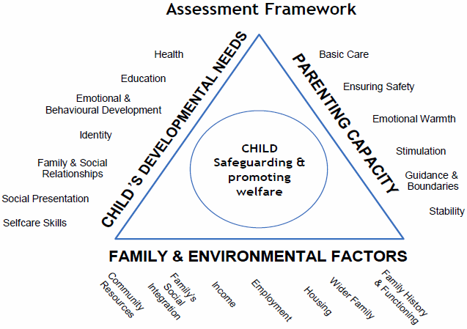

Contact Details SRT.referrals@Stoke.gov.uk phone number is: 01782235100

