Graded Care Profile 2
Measuring care, Helping families

Graded Care Profile 2 – Awareness Sessions
Free

Staffordshire Safeguarding Children Board are launching the NSPCC Graded Care Profile 2 (GCP2) toolkit to help you identify and assess neglect in children across Stoke-on-Trent and Staffordshire.

Find out more about the toolkit and how you can access training and resources when working with families.
Free one-hour awareness sessions are now available for everyone who works with children in Stoke-on-Trent and Staffordshire

Training Sessions

Date | Time | Platform
25 January 2021 | 16:00 – 17:00 | Teams virtual platform
05 February 2021 | 09:00 – 10:00 | Teams virtual platform
11 February 2021 | 14:30 -15:30 | Teams virtual platform
22 February 2021 | 12:00 – 13:00 | Teams virtual platform
24 February 2021 | 18:00 – 19:00 | Teams virtual platform
19 March 2021 | 09:00 – 10:00 | Teams virtual platform
More dates coming soon

Child neglect is the most common reason for a child to be subject to a child protection plan and is featured in 60% of all serious case reviews.
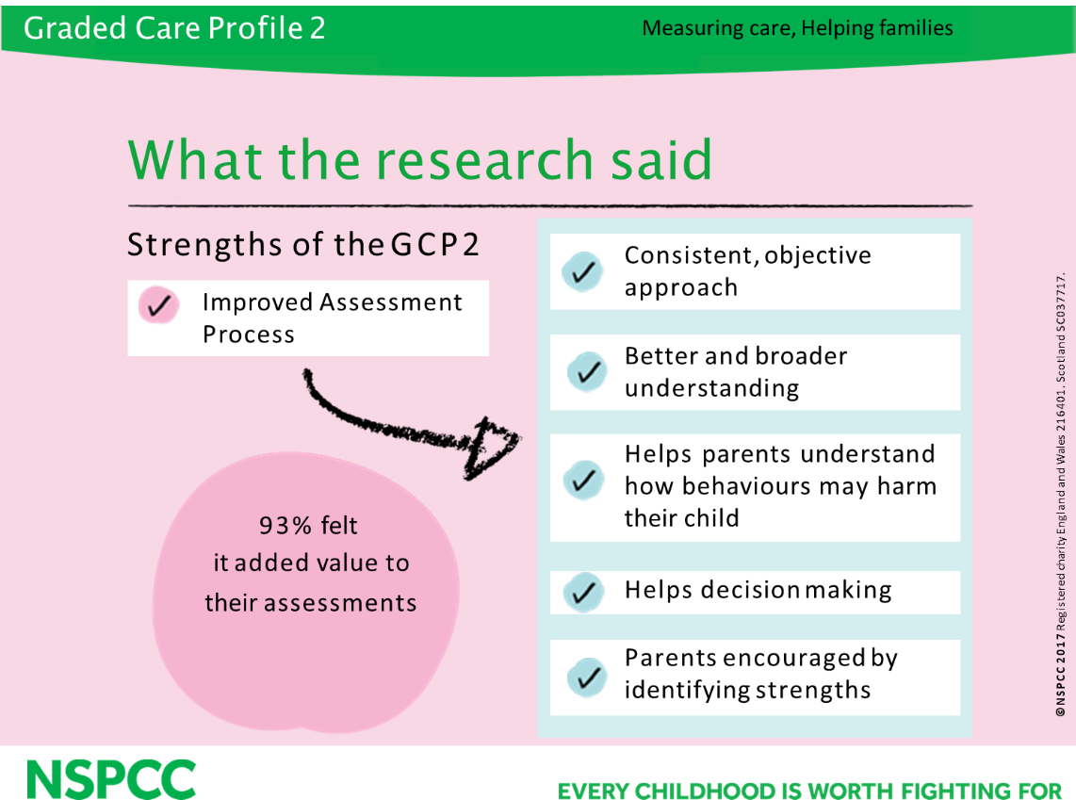

Book your place now

Visit the Leaning Zone

For more information visit www.staffsscb.org.uk

Or contact
sscb.training@
staffordshire.gov.uk

Current situation

- 18 rapid reviews across Stoke-on-Trent and Staffordshire, all but 4 indicated neglect as a significant factor.
- 18 cases, 9 died as a result of a physical injury, 4 survived after suffering fractures as a result of head trauma.
- In 2018/19 the Board received 3 serious incident notifications involving 3 separate families. Prominent feature - neglect, some of which was ‘hidden’ to professionals.
- These cases all met the criteria for a Serious Case Reviews/ Child Safeguarding Practice Reviews
- Of the 7 children involved, 4 died, and 3 suffered long term intra familial sexual abuse.

Graded Care Profile 2

- A comprehensive, practical, evidenced-based assessment tool for evaluating levels of parental care
- A tool that uses a graded scale (1=best 5=worst) to capture levels of physical and emotional care
- Theoretically sound
- A tried and tested tool used across multiple situations and validated by neglect professionals
- A tool that can be used by an individual or groups (Once trained)
- Can be used alongside existing tools

