Working together with Stoke-on-Trent Safeguarding Children Partnership

Early Help Assessment Consent Form

Either you or someone on your behalf is asking for assistance to do with a child or children you are caring for. When a service has been requested it is usually necessary to collect information from other sources in order to make the best assessment of you and your child or family’s needs. These sources may include; Social Services, Schools, GP’s, Police, Probation Service along with any other relevant agencies.

These contacts are important, as the information gathered will help to determine the kind of service that can be provided. We would not usually make these enquiries without your permission. This form is to ask you to give your consent in writing to information being shared by and with other agencies. You can reserve the right to withdraw your consent, however, it will likely make it difficult to further progress your case and provide you with the right type of support.

- The person who has given you this form will discuss with you who might need to be contacted in order that the assessment can be completed.
- The completion of this form ensures that you have had the opportunity to discuss the collection and sharing of information about your family and gives you the opportunity to state whether or not there is anyone that you do not wish us to contact and how that might be.
- If the person giving you this form is from the Local Support Team or a Family Support Provider commissioned by Staffordshire County Council then the attached Privacy Notice (Appendix A) tells you more about how Staffordshire County Council uses your data.

IF THE PERSON GIVING YOU THIS FORM IS FROM ANOTHER ORGANISATION,
PLEASE SEE THE BOX BELOW:

To be inserted by the organisation obtaining consent:
Name of Organisation:
Insert hyperlink to Privacy Notice:
Please state if there is any person or agency you specially do not wish us to contact:
Name of Person or Agency:

Additional comments:

If your family also has unmet needs around worklessness, school absence, anti-social behaviour, family violence or health, then you may meet the criteria for Staffordshire’s Building Resilient Families and Communities Programme. If this is the case your keyworker will explain this to you.
Appendix B (attached) provides information about how the Government will use your data and how you can find out more information about the programme.

Name and Role of practitioner gaining consent:

Children(s) Name(s): | Date of Birth(s):
- I understand that it may be necessary for information to be collected from other agencies to fully assess me and my family’s needs and to produce a plan to meet those needs. I also understand that in order to have the assessment fully completed it may be necessary to share this information with other agencies, organisations and/or individuals
- If I do not agree to the collection and sharing of information I understand that it may not be possible for a full service to be provided.
- Please note that while we would always wish to have written consent before any information is shared, we will proceed without this if there is a reason to believe that child welfare concerns exist.

 |  | Yes | No
I agree to the collection of information to assess my family’s needs:
(This consent is time limited until your family’s case is closed)
I agree to the sharing of information in order to complete an assessment of my family’s needs, to plan for those needs and to review progress.
(This consent is time limited until your family’s case is closed)

FOR FAMILIES SUPPORTED BY STAFFORDSHIRE COUNTY COUNCIL’S LOCAL SUPPORT TEAMS ONLY:

The VOICE Project is part of Staffordshire County Council and meets with young people that have had LST support to find out how well your child feels the service has supported them. We need your consent for someone from the VOICE Project to meet with them in school to discuss this.
 | Yes | No
I agree to the VOICE Project seeing my child in School.
(This consent is time limited until 12 months after your family’s case is closed)..

Names & signatures of people giving consent (who hold parental responsibility):
Surname | Surname
First Name(s) | First Name(s)
Address & postcode | Address & Postcode
Signature | Signature
Print Name | Print Name
Date: | Date:

WITHDRAWAL OF CONSENT

If you decide that you want to withdraw your consent please complete this section and return it to either your keyworker at the address below:
Surname: |  |  | Surname:
First Name(s): |  |  | First Name(s):
Address: |  |  | Address:
Postcode: |  |  | Postcode:

 | Yes | No
I withdraw my consent to the sharing of information in order to complete an assessment of my family’s needs, to plan for those needs and to review progress.
I withdraw my consent to the VOICE Project seeing my child in school.

Signature: |  |  | Print Name: |  | Date:
Signature: |  |  | Print Name: |  | Date:

RETURN ADDRESS (OFFICE BASE FOR TEAM):

APPENDIX A – Privacy Notice
www.staffordshire.gov.uk/yourcouncil/requestandaccessinformation/What-we-do-with-you-personal-information/Privacy-Notice.aspx

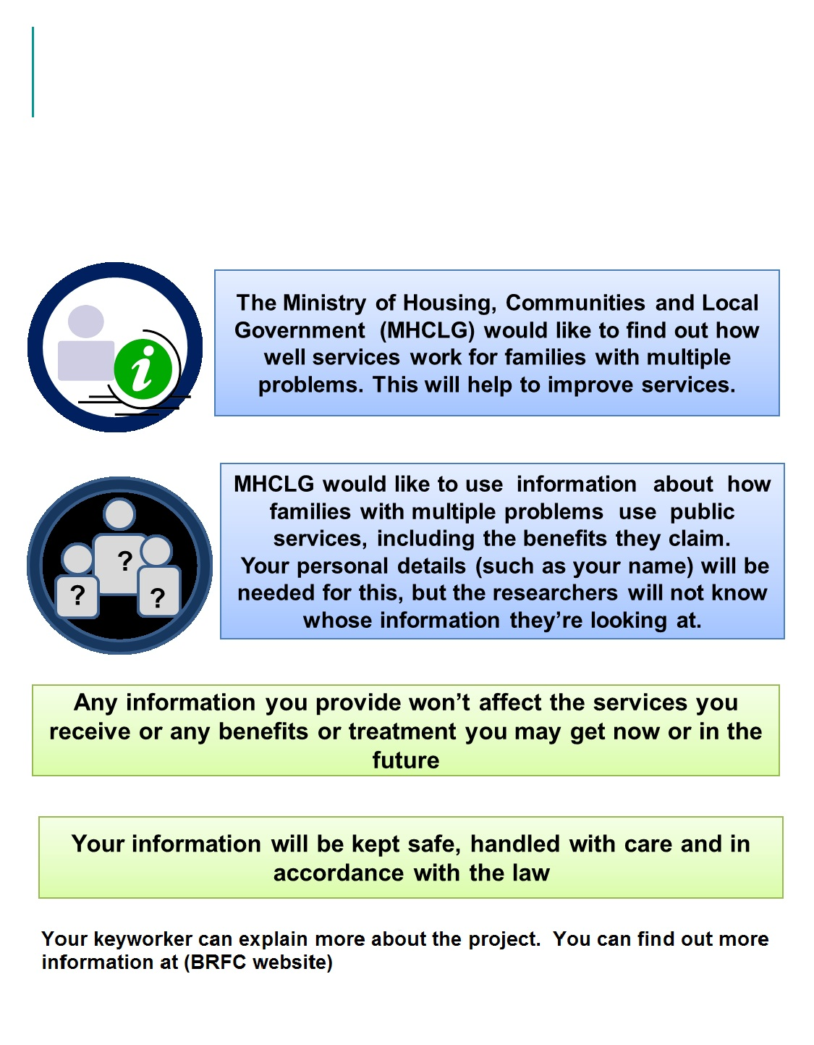
APPENDIX B

