Child Exploitation
Risk Factor Matrix Guidance Notes

This Risk Factor Matrix (RFM) has been developed to be used by practitioners working with children who are thought to be involved in Child Exploitation. The use of the term “child” in this document refers to all children under the age of 18, as defined in the Children Act 1989. However, it may be used by practitioners working with young people over 18 who have a learning difficulty or where there are competence concerns.

When to complete the RFM:
- Complete the RFM as soon as risk is identified, ideally with the child present and engaged.
- Give as much detail as possible around why indicators have been selected in the comments boxes provided; including sources of information, whether suspected or observed and whether recent or non-recent.
- When selecting risk level, if you are unsure please consult with appropriate partner agencies or seek managerial/supervisory support.
- It is recommended that the form is completed electronically for ease of review.
- LiquidLogic users are required to complete the RFM within LCS – under ‘forms’.

Assessing Risk Level:
When considering risk level, select one of the five possible indicators within each box and count the numbers to the left of the risk indicator chosen.

Record the numbers in the score box at the end of the RFM which will give you an overall score. This can then be reviewed up to three times after initial completion (following this, it is advised that a new RFM is completed).
When you have collated each of the score, total them up and review them against the threshold indicator which will identify which risk level is the outcome:

If on completing the RFM, you feel the score does not reflect your view of risk, there is a section below where you can override the scoring system to clarify which level of risk you feel the child is at based on professional judgement.

For Children assessed Medium or High Risk only the completed RFM will also act as a referral into the Multi-Agency Child Exploitation (MACE) Panel.
Securely send all completed RFMs to the following email addresses:

Angela.davenhill@stoke.gov.uk
ChildExploitation@stoke.gov.uk

When reviewing the RFM:

Please ensure that any crosses put in previous sections to show risk level are moved to the current view of risk:
For example, if 3 was previously identified however this has reduced to number 1 – the cross must be moved. Please do not have multiple crosses in one section. Only one indicator can be chosen.

When updating the form, the “multi-agency evidence” section must have an updated date and comments. Please do not delete previous comments just add to them as below:
When scoring risk at the end of the form, please ensure that the scores from the initial completion are left on the form and only the Review scores are added to as below:
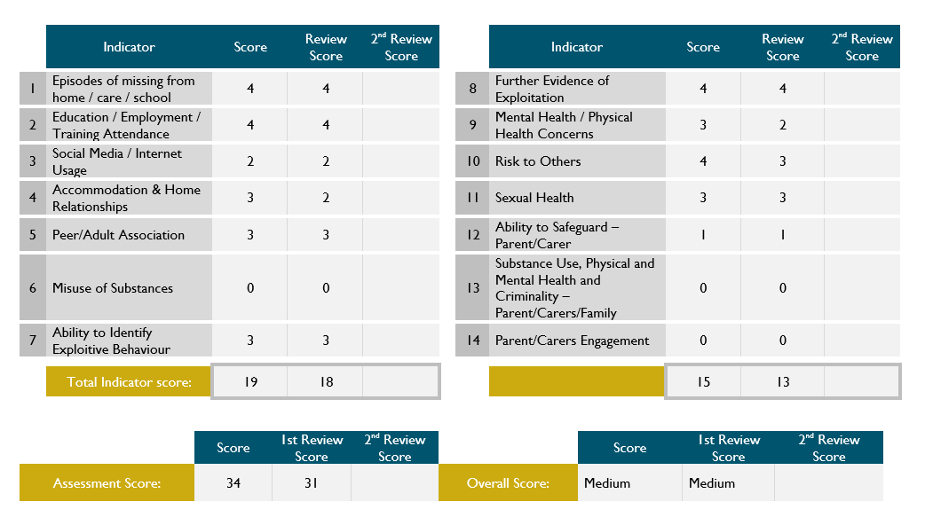
This is the overall risk level
This is calculated by adding up the two review scores (See blue arrows)

This is calculated by adding up the two initial completion scores (See blue arrows)

