Child Exploitation Practice Guidance
Introduction
Stoke on Trent and Staffordshire Safeguarding Board have adopted a revised Child Exploitation Strategy (https://www.ssscb.org.uk/working-together-to-safeguard-children/child-exploitation/) which has been approved by all partners and focuses on tackling all types of child exploitation including child sexual exploitation and child criminal exploitation (including “county lines”).
Whilst Stoke on Trent local authority and their partners have had clear processes and procedures in place to address child sexual exploitation for some time, it has become more apparent that nationally, and locally, children can also be exploited in other ways.
As a result of these revised focus, processes and procedures it is the aim that all children who are identified as at risk of, or experiencing, child exploitation will receive the correct support at the right time to enable them to live safely and thrive.
What is Child Exploitation?
The Child Exploitation Strategy adopts the following definitions;
Child sexual exploitation is a form of child sexual abuse. It occurs where an individual or group takes advantage of an imbalance of power to coerce, manipulate or deceive a child or young person under the age of 18 into sexual activity (a) in exchange for something the victim needs or wants, and/or (b) for the financial advantage or increased status of the perpetrator or facilitator. The victim may have been sexually exploited even if the sexual activity appears consensual. Child sexual exploitation does not always involve physical contact; it can also occur through the use of technology. (Dept. for Ed: Definition and a guide for practitioners, local leaders and decision makers working to protect children from child sexual exploitation, Feb 2017)
Child Criminal Exploitation (CCE) occurs where an individual or group takes advantage of an imbalance of power to coerce, control, manipulate or deceive a child or young person under the age of 18 into any criminal activity (a) in exchange for something the victim needs or wants, and/or (b) for the financial or other advantage of the perpetrator or facilitator and/or (c) through violence or the threat of violence. The victim may have been criminally exploited even if the activity appears consensual. CCE does not always involve physical contact; it can also occur through the use of technology. (Home Office: Serious Violence Strategy, April 2018)
County lines is a term used to describe gangs and organised criminal networks involved in exporting illegal drugs into one or more importing areas within the UK, using dedicated mobile phone lines or other form of “deal line”. They are likely to exploit children and vulnerable adults to move and store the drugs and money and they will often use coercion, intimidation, violence (including sexual violence) and weapons. (Home Office: Criminal Exploitation of children and vulnerable adults: County Lines guidance, Sept 2018

There is also significant cross over with other areas of safeguarding and enforcement including;
Radicalisation refers to the process by which a person comes to support terrorism and extremist ideologies associated with terrorist groups. (HM Govt: Prevent Duty for England and Wales, July 2015)
'Modern slavery' is a term which encapsulates slavery, servitude, forced or compulsory labour and human trafficking. (Modern Slavery Act, 2015).
Child trafficking is defined as the “recruitment, transportation, transfer, harbouring or receipt” of a child for the purpose of exploitation. (United Nations: Palermo Protocol to the United Nations Convention against Transnational Organised Crime, 2000)
Stoke on Trent Approach to Child Exploitation
Stoke On Trent Local Authority has supported the development and implementation of the Child Exploitation Strategy.
We have committed to;
- Support everyone to recognise all forms of child exploitation and raise awareness regarding child criminal exploitation in particular
- Improve our ability to protect children who are being, or are at risk of, child exploitation through adopting a contextual safeguarding approach to child exploitation
- Establish a problem-solving, multi-agency forum to disrupt child exploitation and
- Ensure that there is clear governance and oversight of Child Exploitation

In order to achieve these aims of safeguarding children who are at risk of, or experiencing, child exploitation Stoke on Trent Local Authority and their partners have;
- Developed a raising awareness webinar to inform and support practitioner’s understanding https://view.pagetiger.com/open-to-all/child-exploitation
- Revised the risk factor matrix (RFM) to include all elements of child exploitation (https://www.ssscb.org.uk/working-together-to-safeguard-children/child-exploitation/vamap/)
- Developed services and support for children who are identified as low risk of CE
- Piloted, and now launched, the revised Multi Agency Child Exploitation (MACE) Panel where children who are assessed as medium or high risk will be discussed
- Worked with the National Working Group to develop our processes and gained their support to embed best practice
- Established a Child Exploitation Steering Group to oversee the themes and areas for development presented by national and local research and the feedback from MACE
- Commenced collaboration with the National Tackling Child Exploitation Project which will aim to support Stoke on Trent, Staffordshire and partners in assessing their effectiveness including the impact on children, families and communities.

When I think about that time, even
now I feel very scared. It was a very hard time. I felt I had no choices’.
Young male

Recognising Child Exploitation
Children who are experiencing exploitation can often be labelled by professionals as making “bad choices” or “taking risks”. However, children who are experiencing child exploitation have been groomed over a period of time. This targeted grooming often isolates children from family, schools and other protective factors. It can make them distrustful of professionals and scared to speak out.

The Childrens Society have produced a helpful explanation of the stages of recruitment which can be used with children and families and/ or by practitioners to aid understanding of a child’s situation.

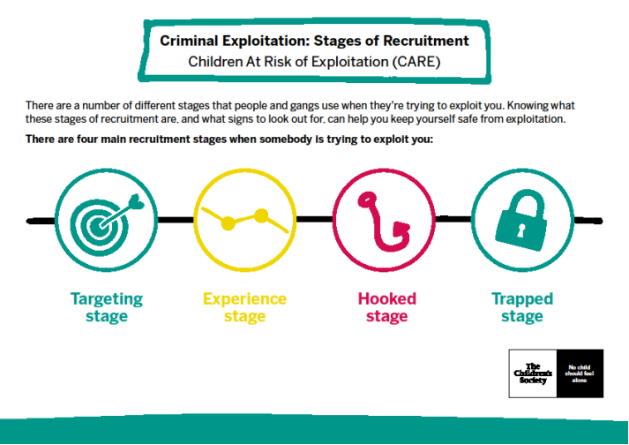
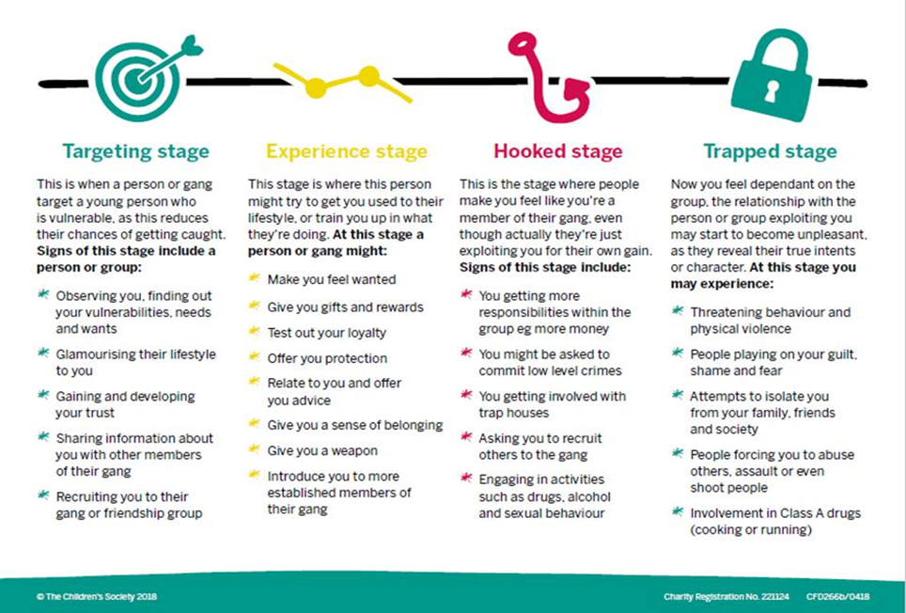

Vulnerability Factors

Any child can be targeted and exploited. However, there is some evidence that certain factors place children at greater risk. The following vulnerabilities do not mean that a child or young person will be exploited, but they are factors that could increase the vulnerability that they could be exploited by someone.

NEIGHBOURHOODS: If the child or young person has been exposed to or has experienced violent crime, or lived in a deprived neighbourhood.

SCHOOLS: If the child or young person has been excluded from school and is not in education, training or employment, or is exposed to or has experienced violent crime.

PEERS: If the child or young person is exposed to other children and young people who are known to be exploited, or exposed to or experiencing peer on peer abuse.

HOME/FAMILY: If there is neglect/abuse, exposure to or experience of violence, parental substance misuse, mental health and domestic abuse, poverty, lack of a positive relationship with a protective and nurturing adult, homelessness or insecure accommodation status

CHILD/INDIVIDUAL: If a child or young person is looked after, has learning disabilities, substance misuse issues, or mental health problems.

Warning Indicators
There are a number of indicators listed in the following table that could alert professionals to a child or young person being criminally exploited. Practitioners should be aware of these warning indicators and if there are concerns should seek support from their line manager/ safeguarding lead and complete a risk factor matrix.

Frequent missing episodes and being found out of area.
Been found out of area when missing, or being arrested out of area — especially for drug related offences.
Returned from missing episodes with injuries, or dishevelled appearance.
Reports of being taken to parties, people’s houses, unknown areas, hotels, nightclubs, takeaways or out of area by unknown adults
Unexplained absences from, or not engaged in school, college, training, or work.
Found with large quantities of drugs or weapons.
Found with drugs inside rectum or vagina.
Unexplained amounts of money, mobile phones, credit, clothing, jewellery, new haircuts or other items and gifts.
Multiple referrals for incidents in the same location
Change in behaviour, i.e. more secretive, withdrawn, or isolated from peers, or not mixing with usual friends.
Increasingly disruptive, hostile or physically aggressive at home or school, including the use of sexualised language and language in relation to drug dealing and/or violence.
Expressions around invincibility or not caring about what happens to them.
Increased interest in making money.

Concerns Regarding Child Exploitation
If is everyone’s responsibility to safeguard children from child exploitation. If you have concerns that a child is at risk, or experiencing, child exploitation then you will need to; speak to you manager or safeguarding lead and complete a risk factor matrix. It is important that you draw on information from other professionals in order to fully complete the RFM. This will provide you with necessary information to assess their risk. Key professionals with whom to discuss may include; Childrens Services, Early Intervention Services, Education, Health and Police. Where appropriate, parents should also be consulted and remain informed of any concerns. The risk factor matrix can be found here https://www.ssscb.org.uk/working-together-to-safeguard-children/child-exploitation/vamap/ and will support you in considering the extent of the risk, but it also includes a professional override that can be used is you feel that your concerns raise or lower the risk.

If a child is considered to be low risk of child exploitation there are services such as catch 22 or the Youth Offending Service that can support you to work with the child on educating and supporting the child around child exploitation.
If a child is considered medium or high risk of child exploitation then they may require intervention from Children’s Services. They will be discussed at MACE and as the referrer you will be asked to attend to share your concerns.
The Role of The Multi Agency Child Exploitation Panel
The MACE meets fortnightly and discusses children who are at medium or high risk of child exploitation. However, this does not replace other statutory meetings such as Child Protection or Child in Need Meetings. MACE is not intended as a case management forum but meets to understand the risk that a child/ group of children is at and to provide a multi-agency, problem solving approach to disrupt exploitation.
My Role in Tackling Child Exploitation
Children who are experiencing child exploitation have been groomed and their groomers are likely to have promoted a dependant relationship. Therefore, children experiencing exploitation may describe their actions as choices that they have made, but this is in the context of exploitation and should not be taken at face value.
It has been well documented that fear of violence and actual physical violence is used to ensure that children remain in the exploitative relationships. Therefore, children experiencing exploitation may also be scared and reluctant to talk to professionals. Despite this there have been a number of examples where, working with partners, children within our city have been safeguarded, supported and protected from exploitation.
It has been highlighted that children who are at risk of, or experiencing, child exploitation who have a trusted adult with whom they can talk are likely to have better outcomes. Therefore, listening (and believing) a child and investing in that relationship can make a significant difference to the child and family.
It is important that all professionals understand the vulnerability factors and the warning indicators discussed within this guidance. Identifying child exploitation creates better outcome for the child, family and communities. This will enable us to achieve the stated aims of the Stoke on Trent and Staffordshire child exploitation strategy which is;
“to make Stoke and Staffordshire an area free from child exploitation, where victims are supported and where perpetrators are held to account for their actions and face the full extent of the law.”

